Final Project Design Phase
Computer Science - Week 11
Oct 3, 2026 - Version 0.0.4

For complete instructions and project ideas, refer to the assignment in Canvas. Specifically, review the final project requirements before you continue below. If you have not reviewed the project requirements in Canvas (you might have to go to the modules view and check the current or past week's content), you will not be able to properly complete the parts below. In addition, it may be helpful to review the information on this Drafter documentation page.

0) Project Planning and Preparation
Successful programmers spend time planning before they begin coding. After reviewing the project requirements, answer the following questions to help guide your design and development process.
- What concepts from class or previous assignments might help you complete this project? Which programming concepts (loops, conditionals, lists, classes, etc.) do you expect to use? What programming skills do you want to improve while completing this project?
I expect to use a lot of programming concepts like loops,conditions,lists,classes and more that we previously learned to complete this project. I want to improve on nested dataclasses and state dataclasses.

- Which parts of the project do you expect to be the easiest for you? The hardest? Why?
I think the easiest part of the project will be planning the dataclasses, routes, pages, variables. I think the hardest part will be incorporating everything into my code and making sure it is complex enough. I think that will be the hardest part because I need to make sure everything fits the requirements and is incorporated correctly into my code.

- Even though you have not yet designed the final project, estimate which tasks will likely require the most time and effort? Which features or components should be implemented first?
I think the parts that will require the most time and effort will be the calculations of the students gpa and assignments priority ranking. I think the calculations should be implemented first so then I can decide how they will be displayed to the user.

- What distractions might interfere with your work and how will you minimize them? What resources will you need available while working? What questions, if any, do you still have about the assignment requirements?
I think some distractions I might face with the project is getting overwhelmed by the different options and approaches of how I can create my code. If I get overwhelmed then I will go for help during office hours.

1) Site Diagram
Create a mock-up of your planned website. We suggest you make the mockup on paper, although you can also use software like PowerPoint or Slides to make a mockup. There is other design software that could also be used, but we strongly encourage you to keep it simple. Do not spend more than 15-30 minutes detailing the mock-up. Your goal should be to make a very quick and dirty diagram, to show that you have some kind of idea.

We recommend drawing each page as a rectangle, and laying out the text, buttons, and other components inside. Then, use arrows to indicate links between pages. Label each page the way you will name each function, and then put labels on the arrows to indicate what the button links. Also write down any parameters that should come into the pages.

In addition to the pages and routes, write down what fields your `State` will have, both their names and types. Think clearly about what data will need to be persistent across the entire website.

Add photo(s) or screenshot(s) of your website mock-up and labeled diagram on the next page.

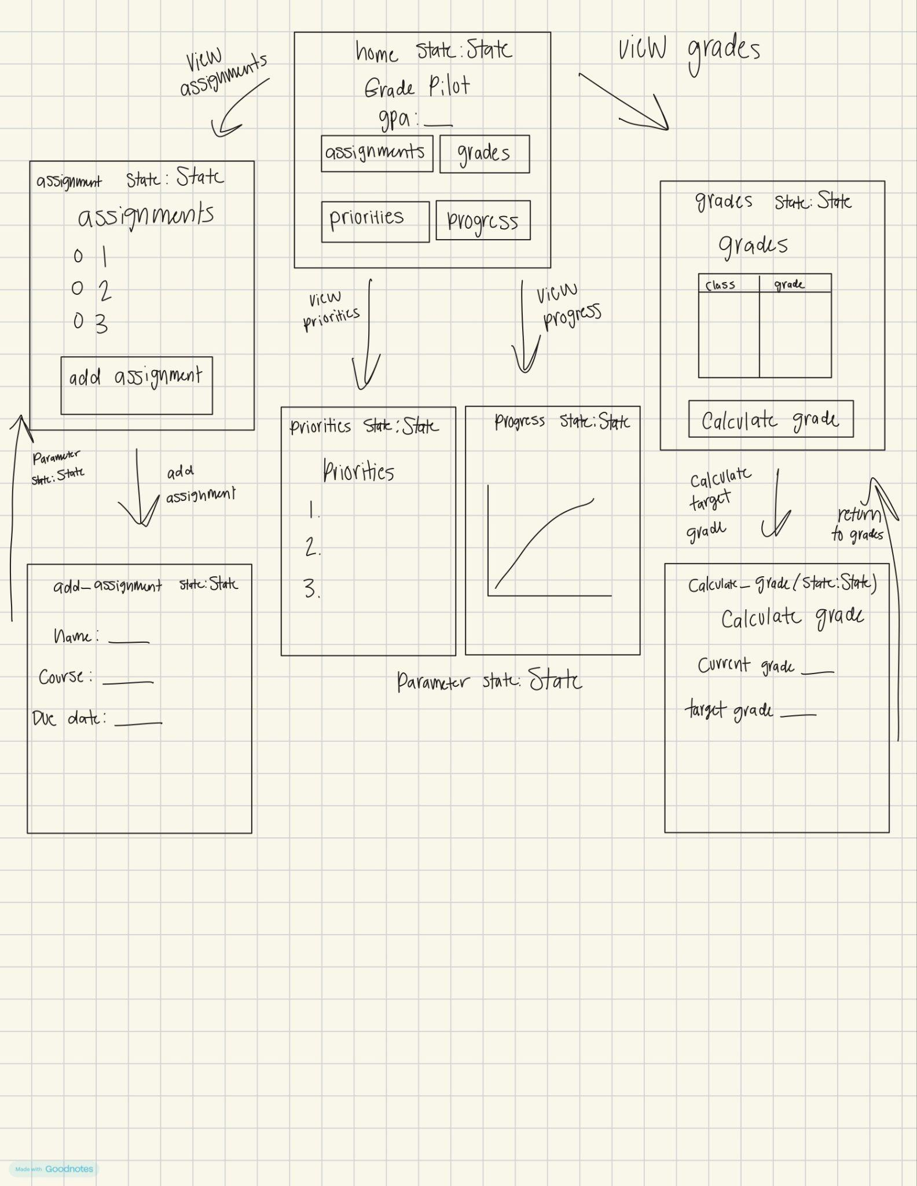

2) Implementing Requirements
This table should serve as a draft for how you will implement the requirements into your final project. You may change your ideas later on, but your final site must fulfill all the requirements.

Requirement | Implementation
Purpose/Functionality  A 1-2 sentence description of the purpose or functionality of your site | The site helps users track assignments, figure out which assignments to prioritize, and be able to calculate and see their academic progress.
State Dataclass Attributes  Minimum of 4 attributes, one of which must be a list/dict of instances of your second dataclass.  Briefly describe each attribute, its type, and how it will be meaningfully modified throughout the site. | State Dataclass:  assignments: list[Assignment] (stores the second dataclass and updates when assignments are changed)  courses : list[Course] (holds the students classes and updates when courses are added or taken away)  selected_course : str (holds the course that's selected and is modified when the students selects a different class)  target_gpa : float (the students desired GPA and changed when the students updates their GPA goal)  show_completed: bool (stores which assignments are completed and updates when user switches on or off)  weekly_study_goal : int (the number of minutes the user wants to spend studying and only changes if the user changes it)
Second Dataclass  Your second dataclass, including its attributes, their types, and how they will be meaningfully modified (if they are modified) | Dataclass 1 : Course  name : str (name of the class)  current_grade: float (users current grade in class)  target_grade : float (grade the user wants to get)  weight : float (overall weighted average of class)  The student can add courses and edit the target grade. They can also update the grade once new assignment scores come in.  Dataclass 2 : Assignment  name : str (name of the assignment)  course : str (class the assignment belongs to)  due_date : str (due date of assignment)  difficulty : int (users ranking of difficulty 1-5)  estimated_hours : float (users estimated time needed to finish the assignment)  grade : float (the score the user received if known)  completed : bool (whether the assignment is finished)  priority_score : float (score used to rank assignments)
Routes (minimum 7)  The names of your route functions | home, assignments, add_assignment, grades, calculate_grade, priorities, progress
Pages (minimum 5)  A brief description of the pages in your site | Home dashboard: page that has an overview of grades, assignments, and progress  Assignments: where the user can look at and add assignments  Grades: grade calculator and target grade calculator  Priorities: page that recommends a ranking of assignment priorities  Progress: page that has charts and statistics for the user to view
User Input (minimum 3)  Description of user input components (TextBox, TextArea, CheckBox, or SelectBox) and their purposes  For more information on these input types, see Drafter Documentation. | Assignment name: textbox (where the user inputs each assignment)  course name: textbox (which course the assignment belongs to)  Due date: textbox (used to figure out how soon the assignment is due)  Difficulty ranking 1-5 : selectbox (used to calculate the priority of the assignment  Assignment completion : checkbox (tracks if assignment is completed or not)
If Statements (minimum 3)  Brief description of what will be evaluated in your if statements and how they will meaningfully change the logic of the site | - If statement for assignment completion will check if the user selected completed or not completed for each assignment  - If statement to determine the priority for each assignment based on the user input 1-5. This will be used to rank assignments priorities for user  - If statement to determine is the student reached their target grade and will give feedback on academic progress
Loop (minimum 1)  This loop must iterate over the list/dict of dataclass instances in your State attribute.  Description of this loop and why it is meaningful to the site | The code will include a loop to check how many assignments are completed. It will look at the state show_completed attribute and counts how many have been completed.

LLM Conversation
If you used an LLM in any part of this work, copy and paste every part of that conversation below. Otherwise, you may be given a zero for the assignment. Obviously, these words will not all be yours, and this is the exception to the requirement at the top of this assignment that all responses be in your own words. If you did not use an LLM to assist you in this assignment, simply say so below.
For gradepilot which will be using drafter, help brainstorm a **State Dataclass with a minimum of 4 attributes**one of which must be a list/dict of instances of your second dataclass. with a breif description of each attribute, its type, and how it will be meaningfully modified throughout the site.
the code also needs at least one other dataclass, 7 routes, 5 pages, 3 user inputs, 3 if statments, and 1 loop.
For GradePilot, I recommend building a student dashboard that tracks assignments, calculates grades, prioritizes schoolwork, and monitors academic progress.
We can organize your code so it meets all the programming requirements while still being realistic for a three-week CS1 project using Drafter.

1. Dataclasses
You will need at least two dataclasses. I recommend using Course as your first dataclass and Assignment as your second dataclass. Your State dataclass will contain a list of Assignment instances.

Dataclass 1: Course
Represents each class a student is taking.
Attribute | Type | Description
name | str | Name of the course, such as Biology or Math.
current_grade | float | Current calculated grade in the class.
target_grade | float | Grade the student wants to achieve.
weight | float | Course weighting if calculating an overall weighted average.
How it changes: Students can add courses, edit their target grades, and update their grades as new assignment scores are entered.

Dataclass 2: Assignment
Represents an individual homework assignment, exam, quiz, or project.
Attribute | Type | Description
name | str | Name of the assignment.
course | str | Course the assignment belongs to.
due_date | str | Date the assignment is due.
difficulty | int | Difficulty rating from 1–5.
estimated_hours | float | Estimated time needed to finish.
grade | float | Score received, if graded.
completed | bool | Whether the assignment is finished.
priority_score | float | Calculated score used to rank assignments.
How it changes: Students can create assignments, edit their information, mark them completed, enter grades, and have their priority scores recalculated.

2. State Dataclass
Meets the 4-attribute requirement
The State dataclass is the main storage system for GradePilot. It holds the information that different pages of your website need to access.
I recommend these 6 attributes:
Attribute | Type | Description | How it is modified
assignments | list[Assignment] | Stores instances of the second dataclass, Assignment. | Updated when assignments are added, edited, or deleted.
courses | list[Course] | Stores the student's courses. | Updated when courses are added or removed.
selected_course | str | Stores the course currently being viewed. | Changes when a student selects a different course.
target_gpa | float | Stores the student's desired GPA. | Changes when the student updates their academic goal.
show_completed | bool | Determines whether completed assignments appear in the assignment list. | Changes when the student turns the completed filter on or off.
weekly_study_goal | int | Number of minutes the student wants to study each week. | Changes when the student adjusts their weekly study goal.

Example Python structure
from dataclasses import dataclass, fieldfrom drafter import *@dataclassclass Course: name: str current_grade: float target_grade: float weight: float@dataclassclass Assignment: name: str course: str due_date: str difficulty: int estimated_hours: float grade: float completed: bool priority_score: float@dataclassclass State: assignments: list[Assignment] = field(default_factory=list) courses: list[Course] = field(default_factory=list) selected_course: str = "" target_gpa: float = 3.5 show_completed: bool = False weekly_study_goal: int = 600
This gives you two supporting dataclasses and one State dataclass with six attributes.

3. Seven Drafter routes and five pages
You need at least seven routes and five pages. Remember that a route is a function that handles a URL, while a page is a screen the user sees. Multiple routes can lead to the same page.
Here is the structure I recommend:

GradePilot
Student Academic Dashboard
Page 1: Home Dashboard
Route 1: /
Overview of grades, assignments, and progress.
Page 2: Assignments
Routes 2 and 3
View and add assignments.
Page 3: Grades
Routes 4 and 5
Grade calculator and target simulator.
Page 4: Priorities
Route 6
Ranked assignment recommendations.
Page 5: Progress
Route 7
Charts and study statistics.

Route breakdown
Route | Function | Purpose
1 | home | Displays the main dashboard.
2 | assignments | Displays all assignments.
3 | add_assignment | Adds a new assignment.
4 | grades | Displays current grades.
5 | calculate_grade | Calculates grades and required exam scores.
6 | priorities | Sorts assignments by priority score.
7 | progress | Displays academic progress and graphs.
This gives you exactly seven routes and five distinct pages.

4. Three or more user inputs
Your website needs user input so students can personalize their information.
I recommend these five:
User input | Type | Where it is used
Assignment name | Text | Adding an assignment.
Due date | Date | Determining assignment urgency.
Difficulty rating | Number (1–5) | Calculating priority.
Current grade | Number | Grade calculations.
Target grade | Number | Calculating the score needed to reach a goal.
You can use Drafter forms and input components to collect these values.

5. Three if statements
Your code needs at least three conditional statements. Here are three meaningful examples.
If statement 1: Assignment completion
if assignment.completed: status = "Completed"else: status = "Not Completed"
This determines which assignments appear in the completed and incomplete sections.
If statement 2: Assignment urgency
if days_remaining <= 1: priority = "High"elif days_remaining <= 3: priority = "Medium"else: priority = "Low"
This categorizes assignments based on their deadlines.
If statement 3: Grade goal
if current_grade >= target_grade: message = "You reached your target!"else: message = "Keep working toward your goal!"
This gives students feedback about their academic progress.

6. One or more loops
Your program needs at least one loop. I recommend using a for loop to calculate the number of completed assignments.
completed_count = 0for assignment in state.assignments: if assignment.completed: completed_count += 1
This loop checks every assignment and counts how many have been completed.
You can also use loops to:
- Display all assignments.
- Calculate the average grade.
- Calculate total estimated study hours.
- Find assignments with upcoming deadlines.

7. Final project requirements checklist
Here is how the proposed GradePilot structure satisfies your requirements.
Project planning checklist
8 requirements planned
Check each item as you implement and test it.
State dataclass
Six attributes
At least one other dataclass
Course and Assignment
List of instances of second dataclass
State.assignments
At least 7 routes
Seven proposed routes
At least 5 pages
Five distinct pages
At least 3 user inputs
Five proposed inputs
At least 3 if statements
Three examples
At least 1 loop
Assignment completion counter

My final recommendation
Make GradePilot's main feature its assignment priority calculator. This is what can make your project stand out.
The website should follow this basic process:
- Student enters their courses and assignments.
- Python stores the information in dataclasses.
- Python calculates grades, workload, and assignment priorities.
- Drafter displays the results through pages, charts, and recommendations.
- Students update their assignments and see their dashboard change.
One important technical note: Drafter's state is separate from permanent storage. If you want assignment data to remain after refreshing the browser, you will need to implement browser local storage rather than assuming the State dataclass saves everything permanently.
This design meets the requested structural requirements on paper. You will still need to implement and test all seven routes, five pages, inputs, conditions, and loops in the actual application.

Description of user input components (TextBox, TextArea, CheckBox, or SelectBox) and their purposes (input componetns on drafter)

1. Recommended five user inputs
I would use these five:
Drafter component User input Purpose
TextBox Assignment name Identifies each assignment.
SelectBox Course name Connects assignments to the correct course.
TextBox Due date Allows the program to calculate how soon an assignment is due.
SelectBox Difficulty (1–5) Helps calculate assignment priority.
CheckBox Completed status Tracks whether an assignment is finished.

You can collect the current grade and target grade through additional inputs on your Grades page.
2. How the inputs connect to your dataclasses
This is important because the information entered by students needs to be stored in your Python dataclasses.

Assignment dataclass
Dataclass attribute User input or calculation
name Assignment name TextBox
course Course name SelectBox
due_date Due date TextBox
difficulty Difficulty SelectBox
completed Completion CheckBox
estimated_hours Additional input
grade Grade entered after assignment is graded
priority_score Calculated automatically by Python

Course dataclass
Dataclass attribute User input or calculation
name Course name TextBox
current_grade Grade input or calculated from assignment scores
target_grade Target grade TextBox
weight Course weight input, if needed

State dataclass

These are not necessarily direct user inputs. They store and manage the information throughout the website.
Attribute Type Purpose
assignments list[Assignment] Stores all assignment objects.
courses list[Course] Stores all course objects.
selected_course str Tracks the currently selected course.
target_gpa float Stores the student's academic goal.
show_completed bool Controls completed assignment filtering.
weekly_study_goal int Stores the student's weekly study goal in minutes.

3. How the entire program works
USER INPUTS

Assignment name · Course · Due date · Difficulty · Completion status

PYTHON DATACLASSES

Assignment · Course · State

MATHEMATICAL PROCESSING

Grade averages · Priority scores · Deadline urgency · Workload calculations

GRADE PILOT OUTPUT

Academic dashboard · Assignment recommendations · Grade graphs · Progress tracking

4. My final recommendation
I would keep the five inputs above as your main assignment form, but add separate inputs for grades and academic goals on your Grades page.

That way, your project has:
- Enough user inputs to populate your dataclasses.
- The information needed for mathematical calculations.
- Meaningful reasons to use all your State attributes.
- A connection between user input, Python processing, and website output.
One important distinction: You don't need a separate input for every dataclass attribute. Some attributes, such as priority_score and current_grade, can be calculated automatically by your Python code rather than manually entered by the student.

Final Submission
When you are finished, download this file as a Word Document (docx) and upload the file to the appropriate assignment on Canvas.

